St. John’s Lutheran Church
3rd and Blackwater Ave.
Davis, WV 26260
304-259-5635
www.stjohnsdaviswv.org



April 5, 2026
Resurrection of Our Lord
Thanks for worshipping with us today. We welcome children in the service, but if you think your child becomes disruptive, you can listen to the service in the narthex and the narthex is relatively soundproof. There is also a play area in the back of the sanctuary. We feel it is important for all to be present in worship. If you are visiting with us, please sign our guest book located on the podium in the back of the sanctuary by the stairs. Also, you are welcome to join in the ministries of the congregation.

St. John's Mission Statement: Answering the call to be God’s hands, feet, and voice in the community and the world.

Prayer List

Please continue to pray for these throughout the week. If you would like someone added to the prayer list or removed from the prayer list, please contact Pastor Ruth. Names will be kept on the list for one month unless Pastor Ruth is notified otherwise.

Athena Bonner
Maggie Brown Keane
Dottie Doerle
Pastor Rosemarie Doucette
Pam Eliopulos
David & Nora Faunce
Beth Feinberg
Sarah Gilland
Mary Frances Good
Kenny Helmick
Mary Helmick
Steelie Kisamor
Betsy Martin
Mont Miller
Barbara Peterson
Janet Preston
Bob Schaaf

Anne Schmiedeknecht
Kathy Thomas
Furman Whitehair
Gene Worden
June Yingling

Healthcare/EMS Workers

Announcements

Join us for fellowship time. Come early to church or stay a while afterward to have coffee/tea and goodies or to visit. Bring goodies to share. You can bring your own mug too and help save the environment.

Church Council will meet next Sunday, April 12, following worship.

To stream our service, go to our YouTube channel: https://www.youtube.com/@st.johnslutherandaviswv.

Happening This Week:

Mon 4/6 AA (church narthex) 7:00 PM

Wed 4/8 Bell Choir Rehearsal 5:00 PM

Fri 4/10 Pastor’s Day Off

Upcoming Readings

April 12 Acts 2:14a, 22-32; Psalm 16; 1 Peter 1:3-9; John 20:19-31

1 | ST. JOHN'S FINANCIAL OVERVIEW - Mar 1, 2026
2 | GENERAL CHECKING ACCOUNT | Feb 2026 | Past 6 months | Past 12 months
3 | TOTAL DEPOSITS  (Data provided by Jinx McNeer,  Recording Secretary) | $9,692 | $68,560 | $144,774
4 | Total WITHDRAWALS  (Data provided by Sam Goughnour,  Financial Secretary) | $12,665 | $70,237 | $138,215
5 | Surplus |  |  | $6,559
6 | Shortfall | -$2,973 | -$1,677
7
8 | GRANT CO. BANK Premier Checking Account  (4.18%, $25,000 minimum balance required) |  |  | $59,143
9
14 | CAPITAL CAMPAIGN | Mar 1 | Feb 1 | Jan 1
15 | Portion in the Building Fund checking account (receives no interest) | $130,497 | $130,222 | $72,488
16 | Portion in the ELCA Ministry Growth Fund mutual fund (~4% interest) | $260,000 | $260,000 | $260,000
17 | TOTAL | $390,497 | $390,222 | $332,488

**Friday is Pastor Ruth’s day off. Please do not call unless it is an emergency.
Also, please do not call on workdays before 9 AM or after 9 PM unless it is an emergency.

+ + +
Important Information
Pastor Ruth Bullwinkle: (cell) 304-704-3150 (H) 304-259-2246

Sunday, April 5, 2026
Resurrection of Our Lord
Holy Communion
+ + +
INTRODUCTION

This is the day the Lord has made! Christ is risen, and through him all creation is made new! Indeed, “God shows no partiality” (Acts 10:34): Christ’s resurrection truly brings life to everyone. We sing hymns of praise, gather around sacred words, and proclaim God’s faithfulness, power, and love in the feast of holy communion. With the women at the tomb, we are astonished, elated, and grateful. We depart with joy to proclaim the good news of God’s endless love.

ANNOUNCEMENTS

Preparation for Worship
As you open your mind and your heart to God’s presence in our midst, we invite you to prepare for today’s service as you listen to the organ prelude, which marks the beginning of worship.

PRELUDE Voluntary on “The Strife is O’er” arr. Phil Lehenbauer

Thanksgiving for Baptism

All may make the sign of the cross, the sign that is marked at baptism, as the presiding minister begins.

Alleluia! Christ is risen.
Christ is risen, indeed. Alleluia!

Salvation belongs to our God who is seated on the throne and to the Lamb!
Amen.

Let us give thanks for the gifts of baptism.
Water may be poured into the font as the presiding minister continues.

Merciful God, you are the one who was, who is, and who is to come. You lead us beside still waters. We thank you for the waters of creation: morning dew, gentle rain, roaring waves. We thank you for the waters that nourish us: Red and Yellow Creeks, the Blackwater River, our many springs and wetlands. Blessed are you.
You guide us to springs of the water of life.

Jesus Christ, you are the faithful witness who accompanies us on our journeys. We give you thanks for your life-giving death and resurrection. We praise you for joining us in joy and sorrow. Blessed are you. You guide us to springs of the water of life.

Holy Spirit, you anoint our head with oil and our cup overflows. Break down barriers that divide us. Fill us with the breath of peace. Blessed are you.
You guide us to springs of the water of life.

Holy One, we thank you for the gifts and grace of baptism, and for making us a new creation. We join with saints and angels, giving you honor and praise, now and forever. Amen.

hymn Christ the Lord is Risen Today ELW 369

Greeting

The grace of our Lord Jesus Christ, the love of God, and the communion of the Holy Spirit be with you all. And also with you.

KYRIE
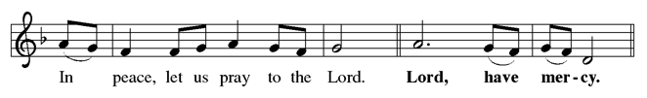
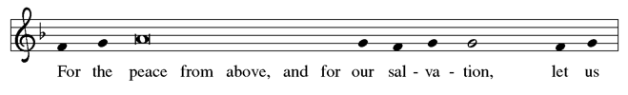
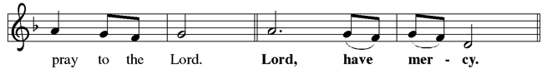
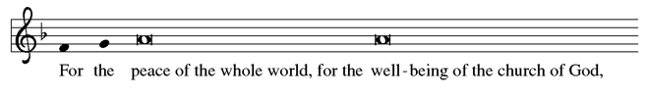
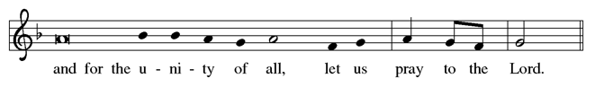


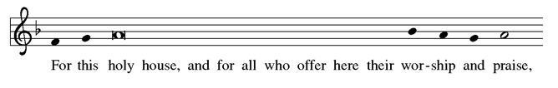
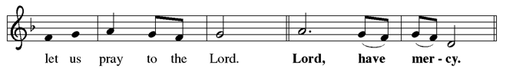
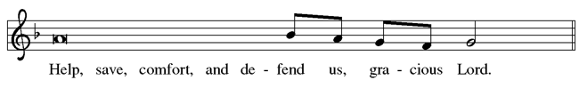


cANTICLE OF PRAISE
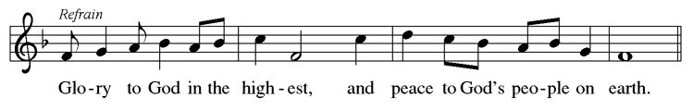
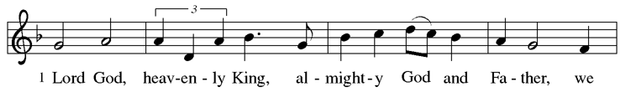
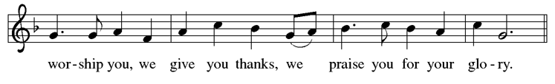
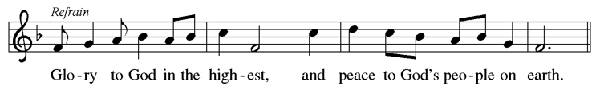
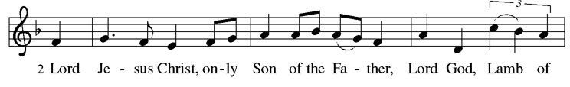
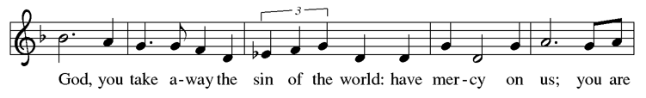
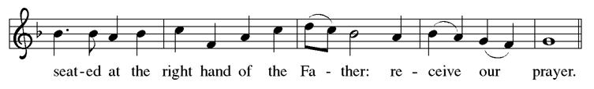
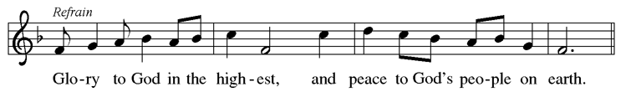
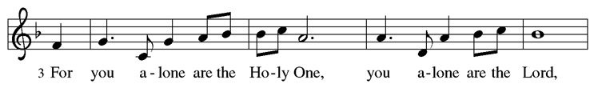
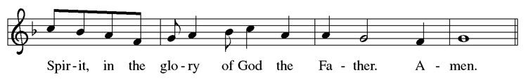
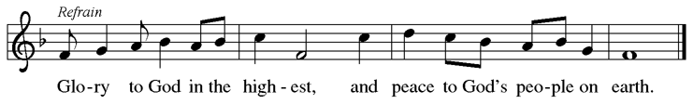

Prayer of the Day

Let us pray. O God, you gave your only Son to suffer death on the cross for our redemption, and by his glorious resurrection you delivered us from the power of death. Make us die every day to sin, that we may live with him forever in the joy of the resurrection, through your Son, Jesus Christ our Lord, who lives and reigns with you and the Holy Spirit, one God, now and forever. Amen.

First Reading: Acts 10:34-43

A reading from Acts.
³⁴ Peter began to speak to [Cornelius and his household]: “I truly understand that God shows no partiality, ³⁵ but in every people anyone who fears him and practices righteousness is acceptable to him. ³⁶ You know the message he sent to the people of Israel, preaching peace by Jesus Christ—he is Lord of all. ³⁷ That message spread throughout Judea, beginning in Galilee after the baptism that John announced: ³⁸ how God anointed Jesus of Nazareth with the Holy Spirit and with power; how he went about doing good and healing all who were oppressed by the devil, for God was with him. ³⁹ We are witnesses to all that he did both in Judea and in Jerusalem. They put him to death by hanging him on a tree, ⁴⁰ but God raised him on the third day and allowed him to appear, ⁴¹ not to all the people but to us who were chosen by God as witnesses and who ate and drank with him after he rose from the dead. ⁴² He commanded us to preach to the people and to testify that he is the one ordained by God as judge of the living and the dead. ⁴³ All the prophets testify about him that everyone who believes in him receives forgiveness of sins through his name.”

Word of God, word of life.
Thanks be to God.

Psalm: Psalm 118:1-2, 14-24 Read Responsively

¹ Give thanks to the Lord, for the Lord is good; God’s mercy endures forever.
² Let Israel now declare, “God’s mercy endures forever.”
¹⁴ The Lord is my strength and my song, and has become my salvation.
¹⁵ Shouts of rejoicing and salvation echo in the tents of the righteous:
“The right hand of the Lord acts valiantly!
¹⁶ The right hand of the Lord is exalted! The right hand of the Lord acts valiantly!”
¹⁷ I shall not die, but live, and declare the works of the Lord.
¹⁸ The Lord indeed punished me sorely, but did not hand me over to death.
¹⁹ Open for me the gates of righteousness;
I will enter them and give thanks to the Lord.
²⁰ “This is the gate of the Lord; here the righteous may enter.”
²¹ I give thanks to you, for you have answered me
and you have become my salvation.
²² The stone that the builders rejected has become the chief cornerstone.
²³ By the Lord has this been done; it is marvelous in our eyes.
²⁴ This is the day that the Lord has made; let us rejoice and be glad in it.

Second Reading: Colossians 3:1-4

A reading from Colossians.
¹ If you have been raised with Christ, seek the things that are above, where Christ is, seated at the right hand of God. ² Set your minds on the things that are above, not on the things that are on earth, ³ for you have died, and your life is hidden with Christ in God. ⁴ When Christ who is your life is revealed, then you also will be revealed with him in glory.

Word of God, word of life.
Thanks be to God.

Gospel Acclamation
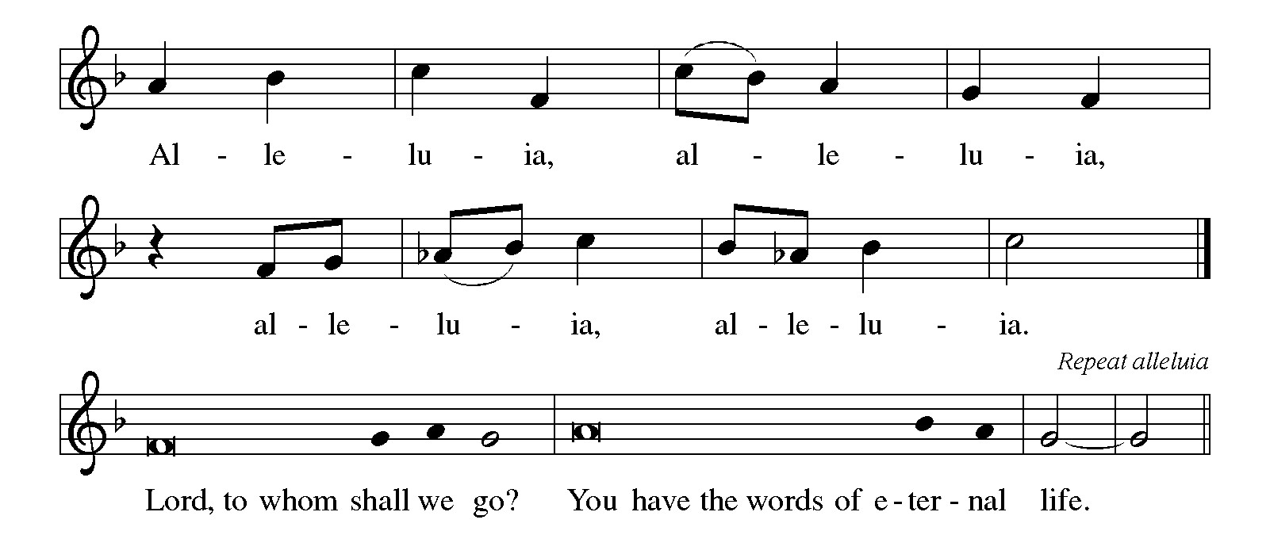

Gospel: Matthew 28:1-10

The holy gospel according to Matthew.
Glory to you, O Lord.

¹ After the Sabbath, as the first day of the week was dawning, Mary Magdalene and the other Mary went to see the tomb. ² And suddenly there was a great earthquake, for an angel of the Lord, descending from heaven, came and rolled back the stone and sat on it. ³ His appearance was like lightning and his clothing white as snow. ⁴ For fear of him the guards shook and became like dead men. ⁵ But the angel said to the women, “Do not be afraid, for I know that you are looking for Jesus who was crucified. ⁶ He is not here, for he has been raised, as he said. Come, see the place where he lay. ⁷ Then go quickly and tell his disciples, ‘He has been raised from the dead, and indeed he is going ahead of you to Galilee; there you will see him.’ This is my message for you.” ⁸ So they left the tomb quickly with fear and great joy and ran to tell his disciples. ⁹ Suddenly Jesus met them and said, “Greetings!” And they came to him, took hold of his feet, and worshiped him. ¹⁰ Then Jesus said to them, “Do not be afraid; go and tell my brothers and sisters to go to Galilee; there they will see me.”

The gospel of the Lord.
Praise to you, O Christ.

SERMON Pastor Ruth Bullwinkle

hymn of the day Christ is Risen! Alleluia! ELW 382

NICENE CREED

We believe in one God, the Father, the Almighty, maker of heaven and earth, of all that is, seen and unseen.

We believe in one Lord, Jesus Christ, the only Son of God, eternally begotten of the Father, God from God, Light from Light, true God from true God, begotten, not made, of one Being with the Father; through him all things were made. For us and for our salvation he came down from heaven, was incarnate of the Holy Spirit and the virgin Mary and became truly human. For our sake he was crucified under Pontius Pilate; he suffered death and was buried. On the third day he rose again in accordance with the scriptures; he ascended into heaven and is seated at the right hand of the Father. He will come again in glory to judge the living and the dead, and his kingdom will have no end.

We believe in the Holy Spirit, the Lord, the giver of life, who proceeds from the Father and the Son, who with the Father and the Son is worshiped and glorified, who has spoken through the prophets. We believe in one holy catholic and apostolic church. We acknowledge one baptism for the forgiveness of sins. We look for the resurrection of the dead, and the life of the world to come. Amen.

Prayers of Intercession

Trusting in the power of Christ’s resurrection to heal and redeem our broken world, let us pray for the needs of all creation.
Risen Savior, you have conquered death and opened the gates of everlasting life. Dispel our doubts and fears and renew our faith and hope in you. Merciful God, receive our prayer.

Life-giving God, the created world rejoices in Christ’s victory over death. May all the earth be renewed by the light of Jesus’ resurrection, and may we be faithful stewards of all you have made. Merciful God, receive our prayer.

Sovereign God, let the nations acknowledge your reign of justice and truth. Where violence, oppression, and corruption hold sway, pour out your holy and life-giving Spirit to transform and redeem. Merciful God, receive our prayer.

Gentle Shepherd, like the women at the empty tomb, many grieve or feel lost and afraid. Draw near to those who are ill or in pain. We pray especially for those on our prayer list and those we now remember in our hearts. Reveal yourself to them as the Risen One. Merciful God, receive our prayer.

Faithful God, we thank you for the living hope you give us through Christ’s resurrection. Bless this community, that we may boldly proclaim Christ’s victory over death in word and deed. Merciful God, receive our prayer.

Eternal One, we give thanks for all who have died and now share in the joy of your resurrection. Bring us, with them, to the unending feast of your victory. Merciful God, receive our prayer.

God of resurrection power, use us and these prayers to proclaim the good news of new life to all the world, through Jesus Christ, our risen Savior. Amen.

Peace

The peace of Christ be with you always.
And also with you.

Offering

An offering is gathered for the mission of the church, including the care of those in need.

hymn during offering Now the Green Blade Rises ELW 379

Presentation of Gifts ELW 182

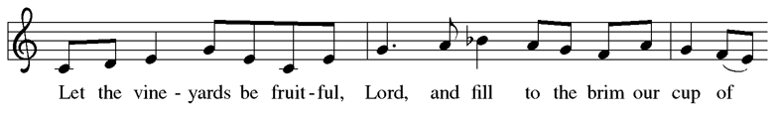
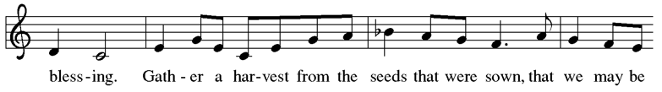
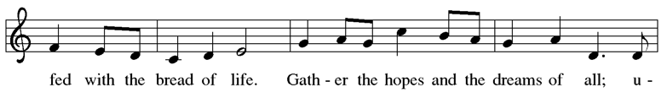
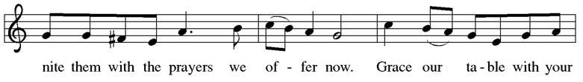
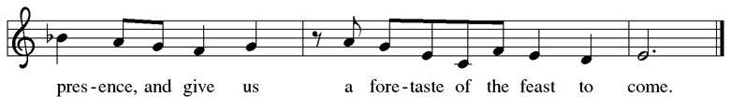



Offering Prayer

Let us pray. Blessed are you, O God, ruler of heaven and earth. Day by day you shower us with blessings. As you have raised us to new life in Christ, give us glad and generous hearts, ready to praise you and to respond to those in need, through Jesus Christ, our Savior and Lord. Amen.

Great Thanksgiving

Dialogue
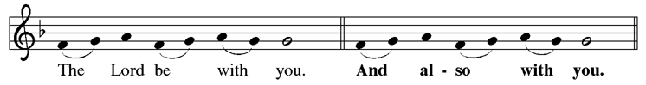
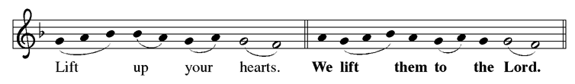
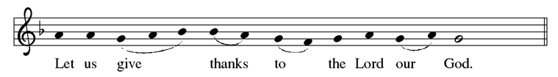
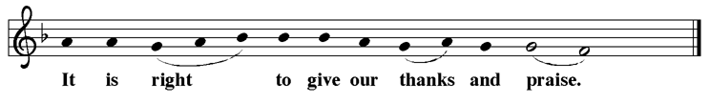

Preface

It is indeed right, our duty and our joy, that we should at all times and in all places
give thanks and praise to you, almighty and merciful God, for the glorious resurrection of our Savior Jesus Christ, the true Paschal Lamb who gave himself to take away our sin; who in dying has destroyed death, and in rising has brought us to eternal life. And so, with Mary Magdalene and Peter and all the witnesses of the resurrection, with earth and sea and all their creatures, and with angels and archangels, cherubim and seraphim, we praise your name and join their unending hymn:

holy, holy, holy
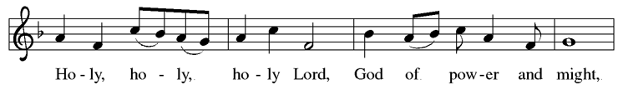
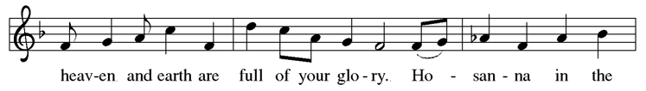
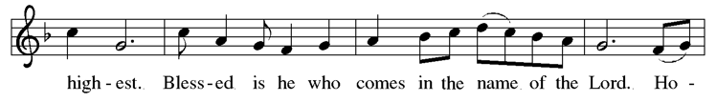
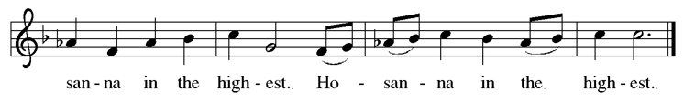

Thanksgiving at the Table

This is the day that in joy and delight we join with all the angels of heaven and all the creatures on earth to sing our praise and thanksgiving to you, all holy and mighty and glorious God. For Christ is risen: Christ is risen indeed.

This is the day that you gave light to the earth. This is the day that you saved the Israelites through the sea and with your pillar of fire led them to freedom.
Now every night is as bright as day, and that light is Christ: Thanks be to God.

This is the day that you broke the chains of death. This is the day that, marrying heaven to earth, you washed away sin, rescued us from evil, and brought us your peace. The Lamb who was slain has begun to reign, for Christ is risen:
Christ is risen indeed.

On the night before he died, our Lord Jesus Christ took bread, and gave thanks,
broke it, and gave it to his disciples, saying: Take and eat; this is my body, given for you. Do this for the remembrance of me.

Again, after supper, he took the cup, gave thanks, and gave it for all to drink, saying: This cup is the new covenant in my blood, shed for you and for all people for the forgiveness of sin. Do this for the remembrance of me.
Let us proclaim the mystery of faith:
Christ has died. Christ is risen. Christ will come again.

On this day send us the power of your Holy Spirit. Revive us with the body and blood of our risen Savior. Illumine our lives with your presence, and shine your Morning Star over the whole human race, for that light is Christ:
Thanks be to God.

All holy and mighty and glorious God, radiant Father, victorious Son, and shining Spirit, we bless your salvation, we sing of your mercy, and we praise your victory through all time and space, for Christ is risen: Christ is risen indeed.

Amen and amen: Amen and amen.

Lord’s Prayer

Gathered into one by the Holy Spirit, let us pray as Jesus taught us.

Our Father, who art in heaven, hallowed be thy name, thy kingdom come, thy will be done, on earth as it is in heaven. Give us this day our daily bread; and forgive us our trespasses, as we forgive those who trespass against us; and lead us not into temptation, but deliver us from evil. For thine is the kingdom, and the power, and the glory, forever and ever. Amen.

Invitation to Communion

Come to the table of grace. Receive the gift of new life.

Communion Instructions

We gather with the saints around the altar rail to receive communion today. Pick up your glass from the tray on the right front pew. There is grape juice in the prefilled glasses in the center of the tray (wine is poured from the chalice into empty glasses by the communion assistant). Dispose of your used glass in the can at the end of the front pew. Gluten-free wafers are available upon request.

lamb of god
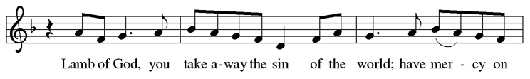
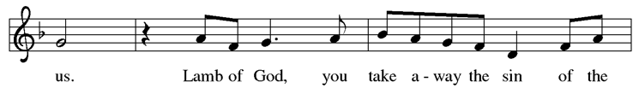
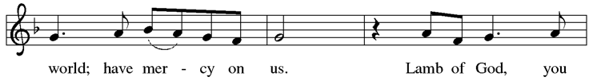
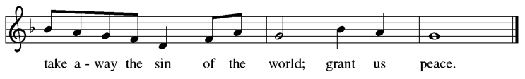

Communion

hymn during communion
You Satisfy the Hungry Heart ELW 484
I Received the Living God ELW 477

Post-Communion Blessing

The body and blood of our Lord Jesus Christ strengthen you and keep you in his grace. Amen.

Prayer after Communion

Let us pray. Life-giving God, in the mystery of Christ’s resurrection you send light to conquer darkness, water to give new life, and the bread of life to nourish your people. Send us forth as witnesses to your Son’s resurrection, that we may show your glory to all the world, through Jesus Christ, our risen Lord. Amen.

Blessing

God Almighty, who is the beginning and the end, Jesus Christ, the firstborn of the dead, and the Spirit, our advocate and peace, ☩ bless you now and forever.
Amen.

Sending hymn Jesus Christ is Risen Today ELW 365
Dismissal

Go in peace. Praise the Lord. Alleluia!
Thanks be to God.

POSTLUDE Jesu, Joy of Man’s Desiring J.S. Bach

From sundaysandseasons.com. Copyright © 2026 Augsburg Fortress. All rights reserved.
Annual License w/Podcasting, Category B average weekly attendance 26 to 100. A-739123 for Jun 12, 2025 - Jun 11, 2026
Annual License with podcasting | B, 26 to 100 average weekend attendance

EASTER LILIES

Given to the glory of God By:
Diane Beall
Melissa & Phill Brown
Pastor Ruth Bullwinkle
Laura Ceperley
John & Thisbe Cooper
Bruce & Andy Dalton
Valerie Dombrowski
Amy & Sam Goughnour
Debby McHenry
Jinx McNeer
Gloria Myers
Kristen Pennington
Holly Plunkett
Harry Utterback



.

