St. John’s Lutheran Church
3rd and Blackwater Ave.
Davis, WV 26260
304-259-5635
www.stjohnsdaviswv.org



September 20, 2026
Seventeenth Sunday after Pentecost
Thanks for worshipping with us today. We welcome children in the service, but if you think your child becomes disruptive, you can listen to the service in the narthex and the narthex is relatively soundproof. There is also a play area in the back of the sanctuary. We feel it is important for all to be present in worship. If you are visiting with us, please sign our guest book located on the podium in the back of the sanctuary by the stairs. Also, you are welcome to join in the ministries of the congregation.

St. John's Mission Statement: Answering the call to be God’s hands, feet, and voice in the community and the world.

Prayer List

Please continue to pray for these throughout the week. If you would like someone added to the prayer list or removed from the prayer list, please contact Pastor Ruth. Names will be kept on the list for one month unless Pastor Ruth is notified otherwise.

Athena Bonner
Maggie Brown Keane & Family
Kelsey Burrow & Family
Niece Steph & Rob Torres
Dottie Doerle
Pam Eliopulos
Beth Feinberg
Maryanne Fink
Family of Sherry Fox
Barbara Peterson
Sarah Gilland
Family of Bernettie Gnegy
Mary Frances Good
Donna Goughnour
Kenny Helmick
Casey King
Steelie Kisamor
Shan Pennington Kuhn
Lloyd Lambert
Mont Miller
Janet Preston
Sam Preston
Bob Schaaf
Melissa Spencer
Jerusha Thacker
Kathy Thomas
Furman Whitehair
Gene Worden
Marsha Worden
June Yingling

Healthcare/EMS Workers

Announcements

Join us for fellowship time. Come early to church or stay a while afterward to have coffee/tea and goodies or to visit. Bring goodies to share. You can bring your own mug too and help save the environment.

Free Community Shred Event – There is a free shredding event at the Mountaintop Public Library on October 10th from 9 AM to 12 PM. Bring your documents for shredding and drop off. Clean out your old files now!

To stream our service, go to our YouTube channel: https://www.youtube.com/@st.johnslutherandaviswv.

Happening This Week:

Mon 9/21 Bell choir 5:00 PM
AA (church narthex) 7:00 PM
Zoom Group Spiritual Direction 7:00 PM

Fri 9/25 Pastor’s Day Off

Upcoming Readings

September 27 Ezekiel 18:1-4, 25-32; Psalm 25:1-9; Philippians 2:1-13; Matthew 21:23-32

1 | ST. JOHN'S FINANCIAL OVERVIEW - Sept 1 2026
2 | GENERAL CHECKING ACCOUNT | August 2026 | Past 6 months | Past 12 months
3 | TOTAL DEPOSITS  (Data provided by Jinx McNeer, Recording Secretary) | $8,521 | $69,227 | $146,349
4 | Total WITHDRAWALS  (Data provided by Sam Goughnour, Financial Secretary) | $10,107 | $74,687 | $144,924
5 | Surplus |  |  | $1,424
6 | Shortfall | $1,587 | $5,460
7
8 | GRANT CO. BANK Premier Checking Account (4.18%, $25,000 minimum balance required) |  |  | $589,972
13
14 | CAPITAL CAMPAIGN | Sept 1 | August 1 | July1
15 | Portion in the Building Fund checking account (~3% interest) | $72,203 | $65,036 | $71,188
16 | Portion in the ELCA Ministry Growth Fund mutual fund (~4% interest) | $260,000 | $260,000 | $260,000
17 | TOTAL | $332,203 | $325,036 | $331,188

**Friday is Pastor Ruth’s day off. Please do not call unless it is an emergency.
Also, please do not call on workdays before 9 AM or after 9 PM unless it is an emergency.

+ + +
Important Information
Pastor Ruth Bullwinkle: (cell) 304-704-3150 (H) 304-259-2246

Sunday, September 20, 2026
Seventeenth Sunday after Pentecost
Holy Communion
+ + +
INTRODUCTION

Matthew narrates one of Jesus’ controversial parables in which Jesus says that the reign of God is like that of a landowner who pays his workers the same wage no matter what time of day they began to work. When God changes God’s mind about punishing Nineveh for their evil ways, Jonah is angry. Yet God is gracious and merciful, abounding in steadfast love. In baptism we receive the grace of God that is f

ANNOUNCEMENTS

Preparation for Worship
As you open your mind and your heart to God’s presence in our midst, we invite you to prepare for today’s service as you listen to the organ prelude, which marks the beginning of worship.

PRELUDE (SONG01)

Confession and Forgiveness

All may make the sign of the cross, the sign that is marked at baptism, as the presiding minister begins.

Blessed be the holy Trinity, ☩ one God, who pours love into our hearts
and healing upon the earth. Amen.

Confident that God justifies us by grace through faith, let us confess our sin.

Silence is kept for reflection.

Compassionate God,
we confess that we struggle to embody your goodness in the world and in our own hearts. Creation groans from overuse. Jealousy and bitterness strain our relationships. Indifference keeps us from seeking justice. Divisions disrupt your call to show genuine love to others. Turn our hearts back to you. Restore our world and reconcile us to one another. Renew us to live as your holy people,
following the way of Jesus Christ. Amen.

Hear this good news: We have peace with God through ☩ Jesus Christ, in whom there is no condemnation, but only forgiveness and the promise of eternal life.
Receive freely this healing gift of grace. Amen.

hymn (SONG02) Lord of Light ELW 688

Greeting

The grace of our Lord Jesus Christ, the love of God, and the communion of the Holy Spirit be with you all. And also with you.

KYRIE (SONG03)
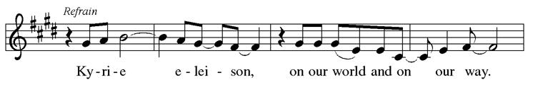
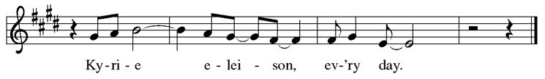
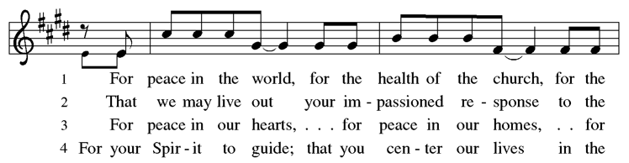
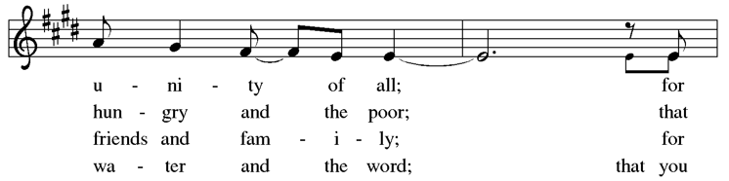
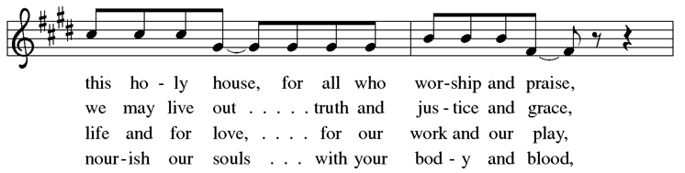

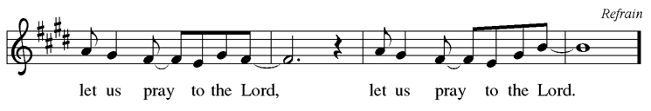

cANTICLE OF PRAISE (SONG04)
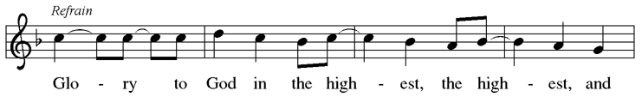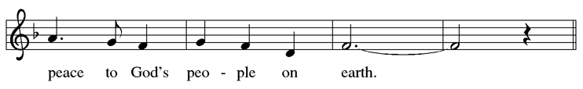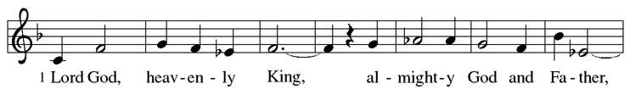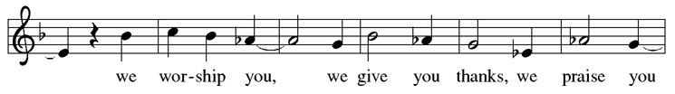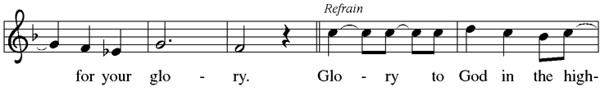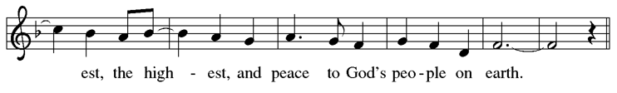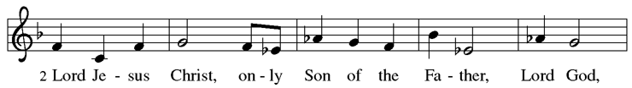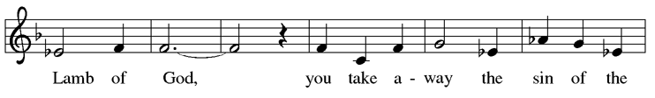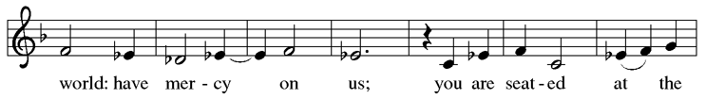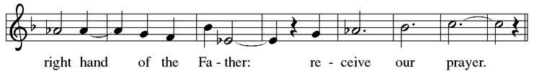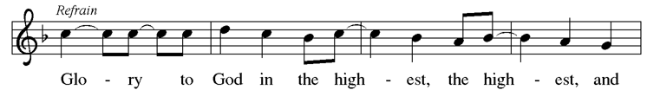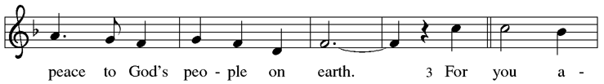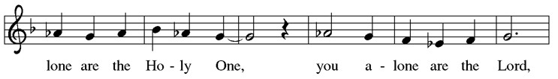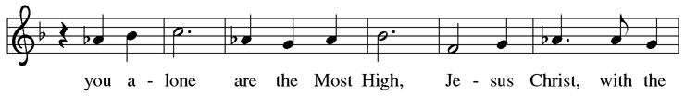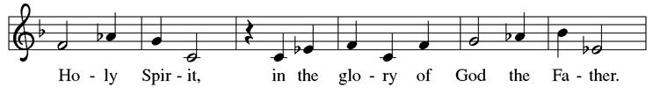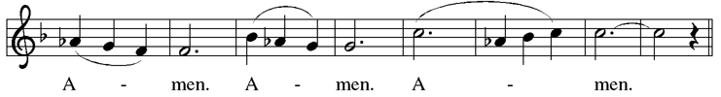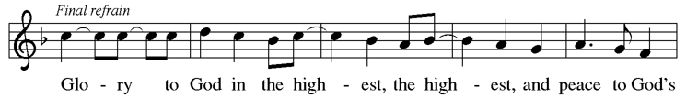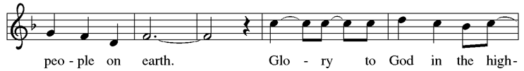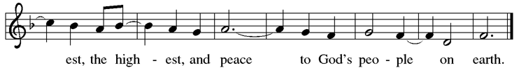

Prayer of the Day

Let us pray. Almighty and eternal God, you show perpetual lovingkindness to us your servants. Because we cannot rely on our own abilities, grant us your merciful judgment, and train us to embody the generosity of your Son, Jesus Christ, our Savior and Lord. Amen.

First Reading: Jonah 3:10—4:11

A reading from Jonah.
¹⁰ When God saw what [the people of Ninevah] did, how they turned from their evil ways, God changed his mind about the calamity that he had said he would bring upon them, and he did not do it.
^{4:1} But this was very displeasing to Jonah, and he became angry. ² He prayed to the Lord and said, “O Lord! Is not this what I said while I was still in my own country? That is why I fled to Tarshish at the beginning, for I knew that you are a gracious and merciful God, slow to anger, abounding in steadfast love, and relenting from punishment. ³ And now, O Lord, please take my life from me, for it is better for me to die than to live.” ⁴ And the Lord said, “Is it right for you to be angry?” ⁵ Then Jonah went out of the city and sat down east of the city and made a booth for himself there. He sat under it in the shade, waiting to see what would become of the city.
⁶ The Lord God appointed a bush and made it come up over Jonah, to give shade over his head, to save him from his discomfort, so Jonah was very happy about the bush. ⁷ But
when dawn came up the next day, God appointed a worm that attacked the bush, so that it withered. ⁸ When the sun rose, God prepared a sultry east wind, and the sun beat down on the head of Jonah so that he was faint and asked that he might die. He said, “It is better for me to die than to live.”
⁹ But God said to Jonah, “Is it right for you to be angry about the bush?” And he said, “Yes, angry enough to die.” ¹⁰ Then the Lord said, “You are concerned about the bush, for which you did not labor and which you did not grow; it came into being in a night and perished in a night. ¹¹ And should I not be concerned about Nineveh, that great city, in which there are more than a hundred and twenty thousand persons who do not know their right hand from their left and also many animals?”

Word of God, word of life.
Thanks be to God.
Psalm: Psalm 145:1-8 Read Responsively

¹ I will exalt you, my God and king, and bless your name forever and ever.
² Every day will I bless you and praise your name forever and ever.
³ Great is the Lord and greatly to be praised! There is no end to your greatness.
⁴ One generation shall praise your works to another
and shall declare your power.
⁵ I will speak of the glorious splendor of your majesty and all your marvelous works.
⁶ They shall tell of the might of your wondrous acts,
and I will recount your greatness.
⁷ They shall publish the remembrance of your great goodness;
they shall sing joyfully of your righteousness.
⁸ The Lord is gracious and full of compassion,
slow to anger and abounding in steadfast love.

Second Reading: Philippians 1:21-30

A reading from Philippians.
²¹ For to me, living is Christ and dying is gain. ²² If I am to live in the flesh, that means fruitful labor for me, yet I cannot say which I will choose. ²³ I am hard pressed between the two: my desire is to depart and be with Christ, for that is far better, ²⁴ but to remain in the flesh is more necessary for you. ²⁵ Since I am convinced of this, I know that I will remain and continue with all of you for your progress and joy in faith, ²⁶ so that, by my presence again with you, your boast might abound in Christ Jesus because of me.
²⁷ Only, live your life in a manner worthy of the gospel of Christ, so that, whether I come and see you or am absent and hear about you, I will know that you are standing firm in one spirit, striving side by side with one mind for the faith of the gospel ²⁸ and in no way frightened by those opposing you. For them, this is evidence of their destruction but of your salvation. And this is God’s doing. ²⁹ For he has graciously granted you the privilege not only of believing in Christ but of suffering for him as well, ³⁰ since you are having the same struggle that you saw I had and now hear that I still have.

Word of God, word of life.
Thanks be to God.

Gospel Acclamation (SONG05)
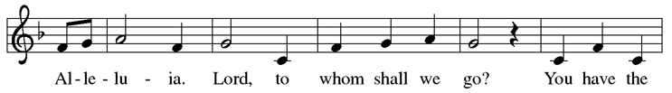
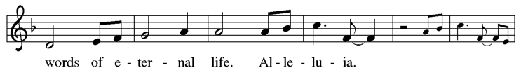
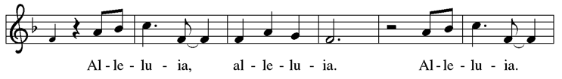
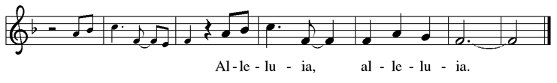

Gospel: Matthew 20:1-16

The holy gospel according to Matthew.
Glory to you, O Lord.

[Jesus said to the disciples:] ¹ “The kingdom of heaven is like a landowner who went out early in the morning to hire laborers for his vineyard. ² After agreeing with the laborers for a denarius for the day, he sent them into his vineyard. ³ When he went out about nine o’clock, he saw others standing idle in the marketplace, ⁴ and he said to them, ‘You also go into the vineyard, and I will pay you whatever is right.’ So they went. ⁵ When he went out again about noon and about three o’clock, he did the same. ⁶ And about five o’clock he went out and found others standing around, and he said to them, ‘Why are you standing here idle all day?’ ⁷ They said to him, ‘Because no one has hired us.’ He said to them, ‘You also go into the vineyard.’ ⁸ When evening came, the owner of the vineyard said to his manager, ‘Call the laborers and give them their pay, beginning with the last
and then going to the first.’ ⁹ When those hired about five o’clock came, each of them received a denarius. ¹⁰ Now when the first came, they thought they would receive more; but each of them also received a denarius. ¹¹ And when they received it, they grumbled against the landowner, ¹² saying, ‘These last worked only one hour, and you have made them equal to us who have borne the burden of the day and the scorching heat.’ ¹³ But he replied to one of them, ‘Friend, I am doing you no wrong; did you not agree with me for a denarius? ¹⁴ Take what belongs to you and go; I choose to give to this last the same as I give to you. ¹⁵ Am I not allowed to do what I choose with what belongs to me? Or are you envious because I am generous?’ ¹⁶ So the last will be first, and the first will be last.”

The gospel of the Lord.
Praise to you, O Christ.

SERMON

hymn of the day (SONG06) Jesus Calls Us O’er the Tumult ELW 696
Apostle’s Creed

I believe in God, the Father almighty, creator of heaven and earth.

I believe in Jesus Christ, God’s only Son, our Lord, who was conceived by the Holy Spirit, born of the virgin Mary, suffered under Pontius Pilate, was crucified, died, and was buried; he descended to the dead. On the third day he rose again; he ascended into heaven, he is seated at the right hand of the Father, and he will come to judge the living and the dead.

I believe in the Holy Spirit, the holy catholic church, the communion of saints, the forgiveness of sins, the resurrection of the body, and the life everlasting. Amen.

Prayers of Intercession

Reminded of God’s gracious and abundant love, we offer our prayers, confident that God hears us.
Hold your church accountable for our unwillingness to share your good news and our anger at your generosity to others. Nourish us by your grace to be witnesses to your love. Hear us, O God. Your mercy is great.

Guide scientists and researchers studying responses to the climate crisis so that all your creation may inspire us to give thanks for your great goodness. Hear us, O God.
Your mercy is great.

Show employers the benefits of equal pay standards for all their employees. Reconcile conflicts between employees. Fill places of employment with camaraderie, and bring an end to employment disparity. Hear us, O God. Your mercy is great.

Encourage any who cannot work or who cannot work a full day with the truth that their value comes from your everlasting love for them. Provide for those who are injured, ill, and in any need. We pray especially for those on our prayer list and those we now remember in our hearts. Hear us, O God. Your mercy is great.

Strengthen all those in this congregation whose labor serves the needs of others in the community. Inspire all in this congregation to support community endeavors with our time and talents. Hear us, O God. Your mercy is great.

Comfort us with the promise of the resurrection as we remember all our loved ones whose desire to be with Jesus is fulfilled. Today we remember Bernettie Gnegy. Hear us, O God. Your mercy is great.

Grant the prayers we have offered, what we have forgotten to ask, and whatever else you see that we need. We ask this in Jesus’ name. Amen.

Peace

The peace of Christ be with you always. And also with you.
Offering

An offering is gathered for the mission of the church, including the care of those in need.

hymn during offering (07) Take My Life that I May Be ELW 685

Presentation of Gifts (song08) ELW 182

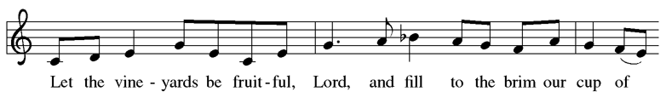
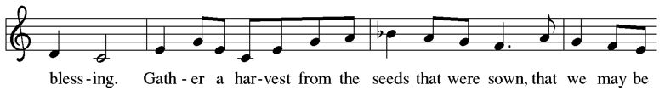
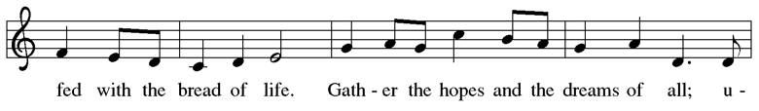
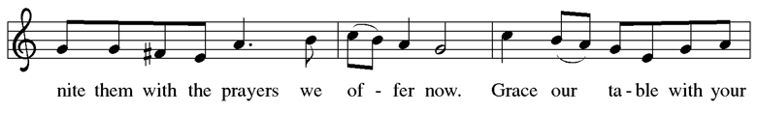
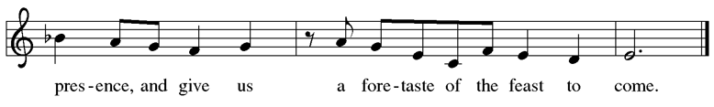

Offering Prayer

Let us pray. God of creation, you send rain and the earth springs forth abundantly. All blessings are from you; make us generous with what we have. Use our gifts, our abilities, and our hearts in service to you and in love to our neighbors, today and always. Amen.

Great Thanksgiving

Dialogue

The Lord be with you.
And also with you.

Lift up your hearts.
We lift them to the Lord.

Let us give thanks to the Lord our God.
It is right to give our thanks and praise.

Preface

It is indeed right, our duty and our joy, that we should at all times and in all places give thanks and praise to you, almighty and merciful God, through our Savior Jesus Christ; who on this day overcame death and the grave, and by his glorious resurrection opened to us the way of everlasting life. And so, with all the choirs of angels, with the church on earth and the hosts of heaven, we praise your name and join their unending hymn:

holy, holy, holy (song09)
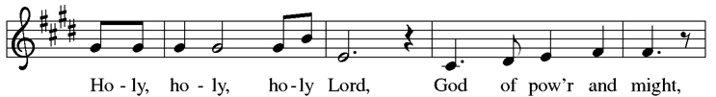
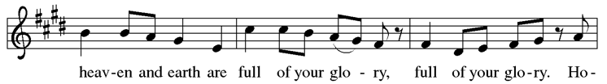
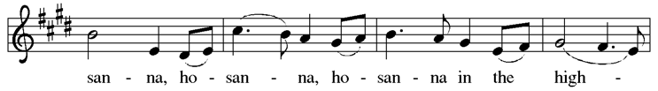
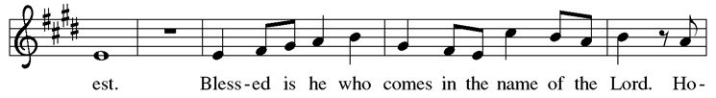
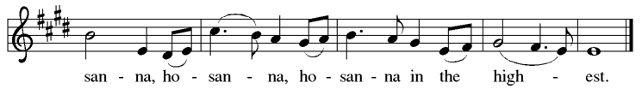

Thanksgiving at the Table: AUTUMN

Holy God,
our Bread of life, our Table, and our Food, you created a world in which all might be satisfied by your abundance.

You dined with Abraham and Sarah, promising them life,
and fed your people Israel with manna from heaven.

You sent your Son to eat with sinners and to become food for the world.
In the night in which he was betrayed, our Lord Jesus took bread, and gave thanks; broke it, and gave it to his disciples, saying: Take and eat; this is my body, given for you. Do this for the remembrance of me.

Again, after supper, he took the cup, gave thanks, and gave it for all to drink, saying: This cup is the new covenant in my blood, shed for you and for all people for the forgiveness of sin. Do this for the remembrance of me.

Remembering, therefore, his life given for us and his rising from the grave,
we await his coming again to share with us the everlasting feast.

By your Spirit nurture and sustain us with this meal: strengthen us to serve all in hunger and want, and by this bread and cup make of us the body of your Son.

Through him all glory and honor is yours, Almighty Father, with the Holy Spirit, in your holy Church, both now and forever. Amen

Lord’s Prayer

Gathered into one by the Holy Spirit, let us pray as Jesus taught us.
Our Father, who art in heaven, hallowed be thy name, thy kingdom come, thy will be done, on earth as it is in heaven. Give us this day our daily bread; and forgive us our trespasses, as we forgive those who trespass against us; and lead us not into temptation, but deliver us from evil. For thine is the kingdom, and the power, and the glory, forever and ever. Amen.

Invitation to Communion

Come to the table of grace. Receive the gift of new life.

Communion Instructions

We gather with the saints around the altar rail to receive communion today. Pick up your glass from the tray on the right front pew. There is grape juice in the prefilled glasses in the center of the tray (wine is poured from the chalice into empty glasses by the communion assistant). Dispose of your used glass in the can at the end of the front pew. Gluten-free wafers are available upon request.

lamb of god (song10)
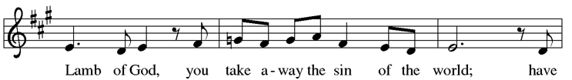
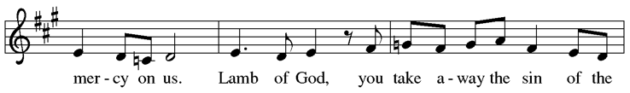
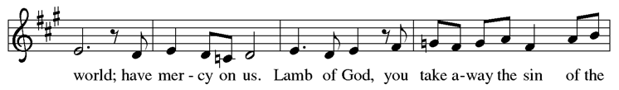
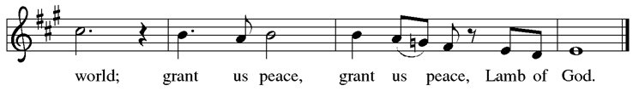

Communion

hymn during communion (song11) Just a Closer Walk ELW 697

Post-Communion Blessing

The body and blood of our Lord Jesus Christ strengthen you and keep you in his grace. Amen.

Prayer after Communion

Let us pray. Sustaining God, with this bread and cup, you nourish us with mercy and abundant life. By your Spirit, send us from this table to serve a needy world. Make us living signs of your liberation, healing, and love, following the way of Jesus, in whose name we pray. Amen.

Blessing

The God of love draw you into full accord and one mind, in the body of Christ Jesus. Amen.

The God of hope grant you strength and joy in all circumstances through the interceding of the Spirit. Amen.

The God of grace ☩ bless you now and forever. Amen.

Sending hymn (song12) Great is Thy Faithfulness ELW 733

Dismissal

Go out in joy. Be led forth in peace.
Thanks be to God.

From sundaysandseasons.com. Copyright © 2026 Augsburg Fortress. All rights reserved.
Annual License w/Podcasting, Category B average weekly attendance 26 to 100. A-739123 for Jun 12, 2026 - Jun 11, 2027
Annual License with podcasting | B, 26 to 100 average weekend attendance.

